



**Contents**

1 Project Abstract 3

2 Problem Statement 3

3 Proposed Product Inventory Management System Wireframe 4

3.1 Welcome Page 4

3.2 Screenshots 5

4 Business-Requirement: 15

5Constraints 21

# Project Abstract

In the ever-evolving field of retail and business management, there is a growing necessity for digital platforms that facilitate efficient inventory tracking, enhance product management capabilities, and empower businesses to optimize their operations. With this vision in mind, the CEO of a product management startup assigns a team of developers with the task of creating a **Product Inventory Management System** using Angular.

Your task is to develop a digital solution that allows businesses to manage their product inventory efficiently by adding, updating, deleting, and listing products. The system should enable users to organize products by categories, update stock quantities, and manage product details such as descriptions, prices, and manufacturers. Additionally, the platform should allow administrators to securely log in, perform inventory actions, and track their inventory in real time.

# Problem Statement

“**Product Inventory Management System**” is a Single Page Application (SPA) designed to enhance inventory management for businesses by simplifying the process of managing products and stock. This system enables businesses to efficiently add, update, delete, list, and search for product records. Users can also categorize products, update stock quantities, and view detailed product information such as descriptions, prices, and manufacturers.

# Proposed Product Inventory Management System Wireframe

UI needs improvisation and modification as per given use case and to make test cases passed.

## Welcome Page

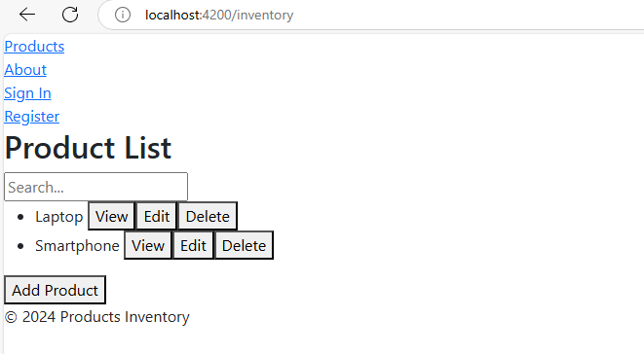

## 

## ScreenShots

**\*\*\*Register\*\*\***

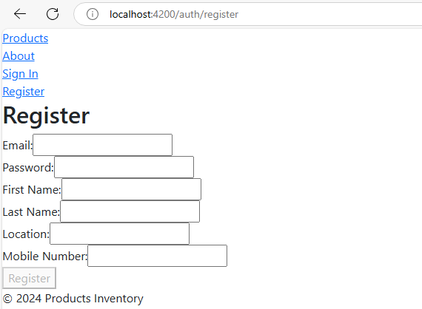

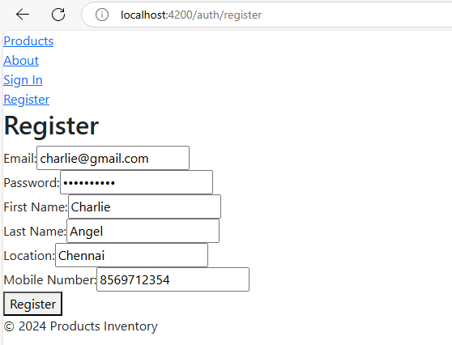

## 

**\*\*\*Sign In\*\*\***

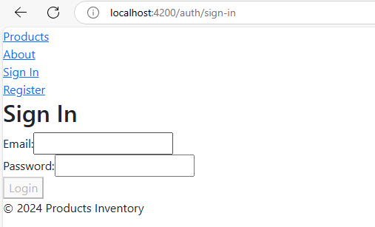

**\*\*\*Already added some users, kindly use their credentials in db.json file\*\*\***

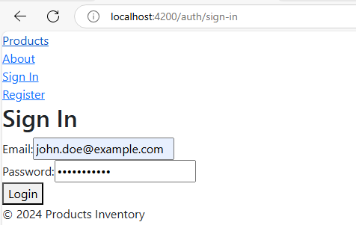

**\*\*\*Signed In as a User\*\*\***

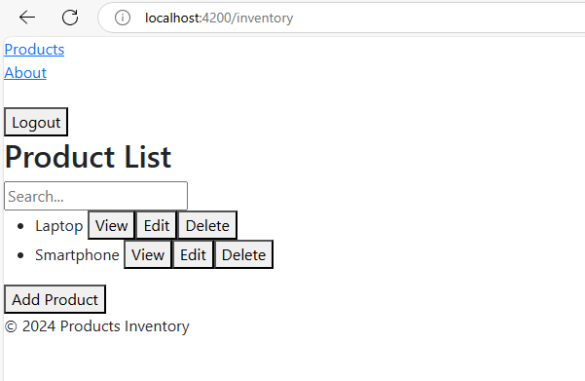

**\*\*\*Add Product\*\*\***

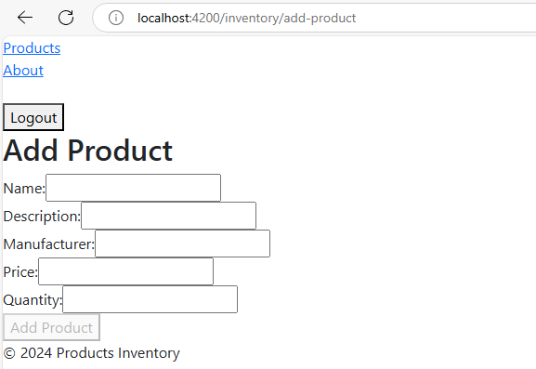

**\*\*\*Already added some products with their details\*\*\***

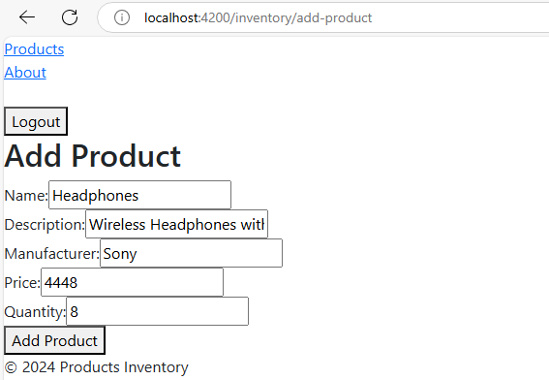

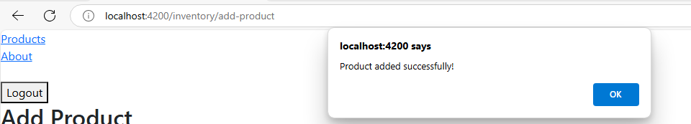

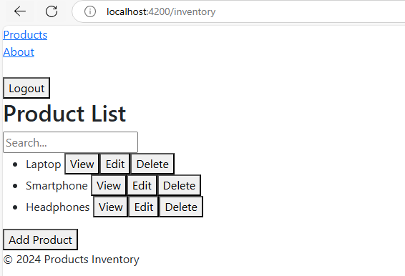

**\*\*\*View Product\*\*\***

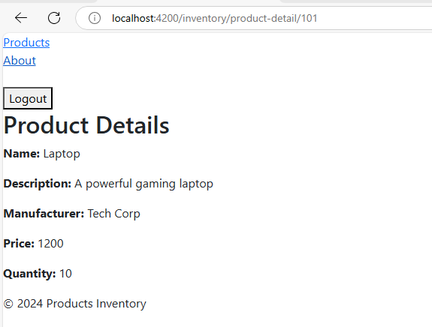

**\*\*\*Edit Product\*\*\***

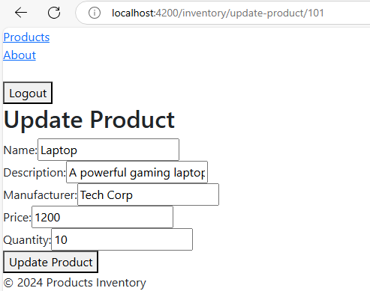

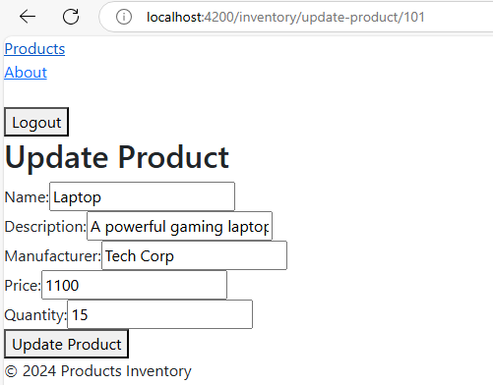

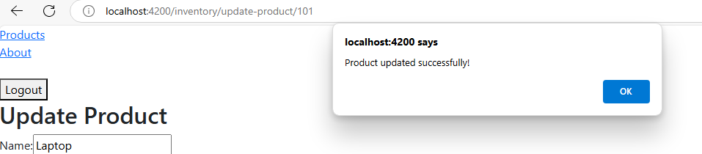

**\*\*\*Delete Product\*\*\***

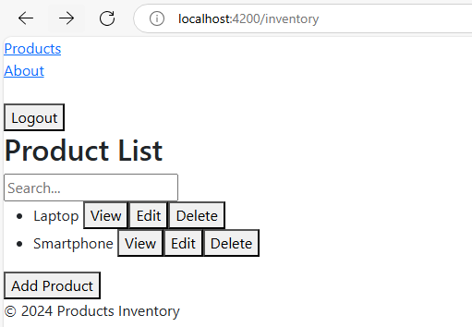

**\*\*\*About\*\*\***

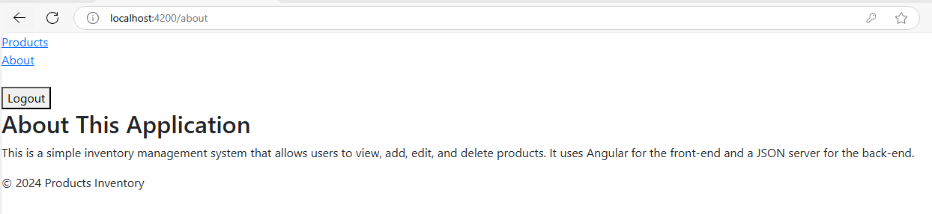

**\*\*\*Validations\*\*\***

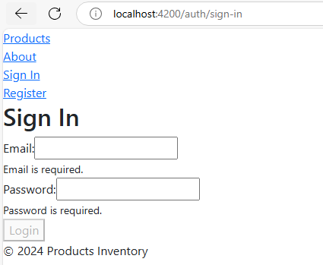

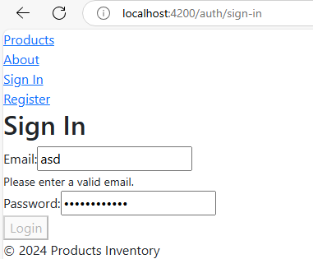

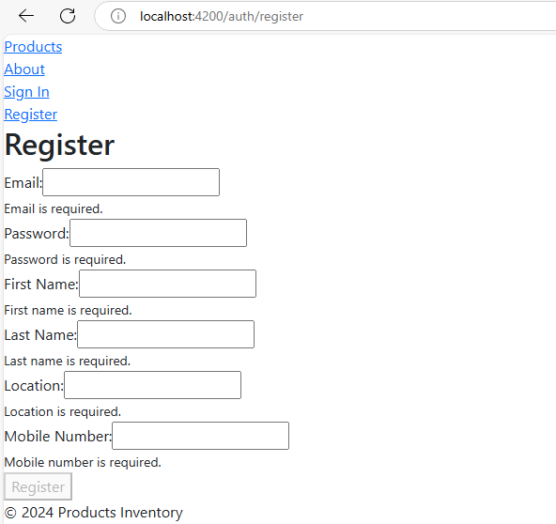

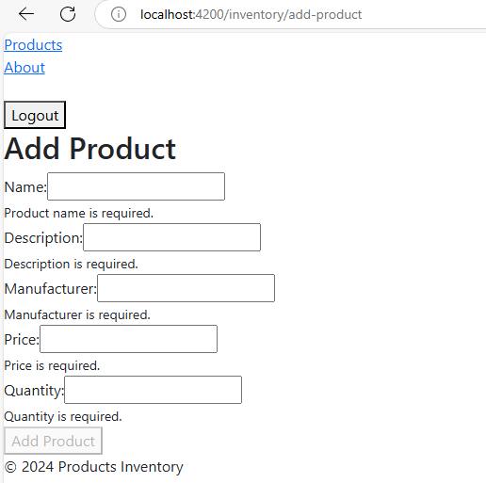

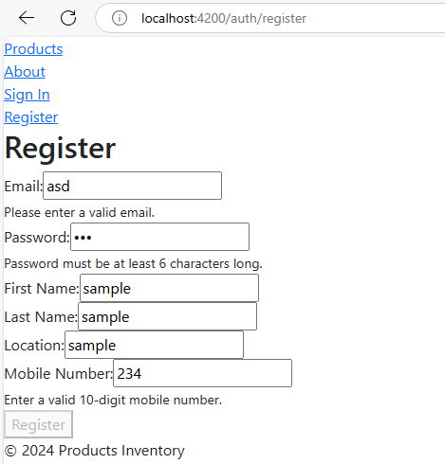

# Business-Requirement:

As an application developer, develop the Product Inventory Management System (Single Page App) with below guidelines:

|  |  |  |
| --- | --- | --- |
| User  Story # | User Story Name | User Story |
| US_01 | Welcome Page | As a user I should be able to visit the welcome page as the default page.  Acceptance criteria:   1. There should be 4 routes/links:  * **Products**: When clicking this link, it should navigate to the home page displaying the product list. * **About:** When clicking this link, it should navigate to the "About" page, providing details about the application. * **Sign In:** When clicking this link, it should navigate to the login page. * **Register**: When clicking this link, it should navigate to the registration page.   The above-mentioned **4 navigation routes/links** should be present and functional across all the respective pages of the Product Inventory System, allowing easy access to any section from anywhere within the app until logging in.   1. The Welcome Page should display the title “**Product List**” as heading in h2. 2. A search bar should be available to filter the products. 3. A list of products should be displayed, where each product includes:  * **Product Name** (e.g., Laptop, Smartphone). * **Action Buttons**:  1. **View** 2. **Edit** 3. **Delete** 4. **Add Product Button**: Clicking this button should redirect to the **Sign In** page until logged in. 5. Any action (View, Edit, Delete, or Add Product) should redirect the user to the **Sign In** page if they are not logged in. 6. You need to use the already implemented footer component to ensure that **"© 2024 Products Inventory"** is displayed on all pages, including after logging in.   **\*\* Kindly refer to the screenshots for any clarifications. \*\*** |
|  | About Page | Acceptance criteria:   1. You need to use the already implemented **About Page** link, it should be able to view the details about the application on the "About" page including after logging in.   The **Products**, **About**, **Sign In**, and **Register** links should be present throughout all the respective pages in the application until logging in.  **\*\* Kindly refer to the screenshots for any clarifications. \*\*** |
|  | Sign In  Register | Acceptance criteria:   1. The page should display the title “**Sign In**” as heading in h2. 2. The page should display a Login form that includes the following fields:  * **Email**: Required field, should display a validation message if left empty as mentioned in screenshots above. * **Password**: Required field, should display a validation message if left empty as mentioned in screenshots above.  1. The form should include a **Login** button to submit the login credentials:  * Should be **disabled by default**. * Should be **enabled** only when both fields are filled correctly.  1. The system should validate the user credentials upon submission and provide appropriate feedback:  * If the credentials are wrong, it should display as mentioned in the screenshot. * Upon successful login, the user should be redirected to the **Home Page**.   The **Products**, **About**, **Sign In**, and **Register** links should be present throughout all the respective pages in the application until logging in.  **\*\* Kindly refer to the screenshots for any clarifications. \*\***  Acceptance criteria:   1. The **Register Page** should display the title: **"Register"** as heading in h2. 2. The form should include the following fields:  * **Email**: Required field, should display a validation message if left empty as mentioned in the screenshot. * **Password**: Required field, should display a validation message if left empty as mentioned in the screenshot. * **First Name**: Required field, should display a validation message if left empty as mentioned in the screenshot. * **Last Name**: Required field, should display a validation message if left empty as mentioned in the screenshot. * **Location**: Required field, should display a validation message if left empty as mentioned in the screenshot. * **Mobile Number**: Required field, should display a validation message if left empty as mentioned in the screenshot.  1. The form should have an "**Register”** button:  * Should be **disabled by default**. * Should be **enabled** only when all fields are filled correctly.  1. Upon successful registration, the user’s details should be registered in db and allowed to sign in.   The **Products**, **About**, **Sign In**, and **Register** links should be present throughout all the respective pages in the application until logging in.  **\*\* Kindly refer to the screenshots for any clarifications. \*\*** |
| US_02 | User’s Page  (When logged in as a User) | As a logged-in user, I should be able to view the list of available products and perform actions like viewing, editing, deleting, or adding new products.  Acceptance criteria:   1. There should be 2 routes/links:  * **Products**: When clicking this link, it should navigate to the home page displaying the product list. * **About:** When clicking this link, it should navigate to the "About" page, providing details about the application.  1. **Logout**: Clicking the logout button should log the user out and redirect them to the **Home** page. 2. You need to use the already implemented footer component to ensure that **"© 2024 Products Inventory"** is displayed on all pages, including after logging out.   The above-mentioned **2 navigation routes/links, logout button, footer** should be present and functional across all the respective pages of the Product Inventory System, allowing easy access to any section from anywhere within the app until logging out.   1. The **Home Page** should display the title: **"Product List"** as heading in h2. 2. A search bar should be available to filter the products. 3. A list of products should be displayed, where each product includes:  * **Product Name** (e.g., Laptop, Smartphone). * **Action Buttons**:  1. **View**: Navigates to the **Product Details** page for the selected product. 2. **Edit**: Navigates to the **Update Product** page for the selected product. 3. **Delete**: Deletes the product from the list. 4. **Add Product Button**: Navigates to the **Add Product** page.   **\*\* Kindly refer to the screenshots for any clarifications. \*\*** |
|  |  | **View Product:**  Acceptance criteria:   1. When clicking the “View” button, I should be able to view detailed information about a selected product. 2. It should display the title “**Product Details**” as heading in h2. 3. The page should show the following details for the selected product:  * **Name**: The name of the product (e.g., Laptop). * **Description**: A detailed description of the product (e.g., A powerful gaming laptop). * **Manufacturer**: The manufacturer of the product (e.g., Tech Corp). * **Price**: The price of the product (e.g., 1100). * **Quantity**: The available quantity (e.g., 15).   **\*\* Kindly refer to the screenshots for any clarifications. \*\***  **Update Product:**  Acceptance criteria:   1. When clicking the “Update” button, I should be able to update the details of a product. 2. It should display the title “**Update** **Product**” as heading in h2. 3. The page should include a form with pre-filled fields for the selected product:  * **Name**: Editable field for the product name. * **Description**: Editable field for the product description. * **Manufacturer**: Editable field for the manufacturer name. * **Price**: Editable field for the product price. * **Quantity**: Editable field for the product quantity.  1. The form should include a **Update** **Product** button to update the respective products:  * It should be **enabled** only when all required fields are filled correctly.  1. Clicking the **Update Product** button should update the product and redirect the user to the **Home Page**.   **\*\* Kindly refer to the screenshots for any clarifications. \*\***  **Delete Product:**  Acceptance criteria:   1. When clicking the “Delete” button, it should delete the product from the list. 2. The product should be removed from the list, and the page should update to show the remaining products.   **\*\* Kindly refer to the screenshots for any clarifications. \*\***  **Add Product:**  Acceptance criteria:   1. When clicking the “Add Product” button, I should be able to add a new product to the inventory. 2. It should display the title “**Add** **Product**” as heading in h2. 3. The page should include a form with the following fields:  * **Name**: Required field for the product name. Should display a validation message if left empty as mentioned in the screenshot. * **Description**: Required field for the product description. Should display a validation message if left empty as mentioned in the screenshot. * **Manufacturer**: Required field for the manufacturer name. Should display a validation message if left empty as mentioned in the screenshot. * **Price**: Required field for the product price. Should display a validation message if left empty as mentioned in the screenshot. * **Quantity**: Required field for the product quantity. Should display a validation message if left empty as mentioned in the screenshot.  1. Add Product Button:  * The button should be **disabled by default**. * It should be **enabled** only when all required fields are filled correctly.  1. Clicking the **Add Product** button should add the new product and redirect the user to the **Home Page**.   **\*\* Kindly refer to the screenshots for any clarifications. \*\***  **Logout Button:**   1. When the "Logout" button is clicked, the user should be immediately logged out of the application. 2. Upon logout, the user should be redirected to the "Welcome" page.   **\*\* Kindly refer to the screenshots for any clarifications. \*\*** |
|  | About Page | Acceptance criteria:   1. When clicking the **About Page** link, I should be able to view the details about the application on the "About" page. 2. You need to use the already implemented **About Page** link, it should be able to view the details about the application on the "About" page.   The **Products**, **About**, **Logout**, and **Footer** should be present throughout all the respective pages in the application until logging out.  **\*\* Kindly refer to the screenshots for any clarifications. \*\*** |

# Constraints

1. You should be able to press the “TAB” key and “SHIFT + TAB” to navigate from top field to bottom field and vice-versa.
2. All required fields must be completed with valid data.
3. When logging into the system, all fields must be filled.
4. When adding or updating a product, all fields are mandatory to be filled.
5. The system should validate invalid entries and display appropriate error messages.